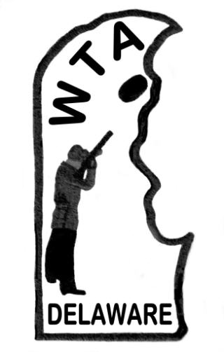
Wilmington Trapshooting Association’s
Appreciation Shoot Honorees

Annually since 1987, WTA has recognized the contributions of individuals who have significantly contributed to the growth and prosperity of the association and the sport of trapshooting in Delaware.

- Gene Anderson 2016 Richard “Dick” Kane
- Henry E. Bearman (Past President) 2017 Ken Petonke
- Louis Rutter 2018 Skeet Field #3 Team
- Allan P. Brown, Jr. 2019 WTA Volunteers
- Steven E. Hastings (Past President) 2020 -
- Joseph F. Falco, Sr. (Past President) 2021 Covid Heroes
- John King 2022 -
- Donald H. Burton 2023 Robert “Bob” Gant
- Carmen N. Stigliano (Past President) 2024 Rickey W. Fortner
- Thelma Clagett 2025 Robert “Bob” Miller
- Dave R. Reynolds (Past President)
- John T. Cini (Past President)
- Michael Szotkiewicz (Past President)
- Sarah Lindsey
- Richard E. Johnson (Past President)
- Stephen J. Nichols and Stephen P. Nichols
- Robert and Doris Cossaboon
- John “Jack” Biggs III
- Steven T. Sechrist
- Linda R. Brown
- Ronald L. Lindsey
- Kent A. Brown
- Dirk Harrington
- Richard and Barbara Cairns
- David Reynolds (Past President)
- Curtis R. Jones
- Edward H. Walker, Jr.
- -
- Merlyn R. Wegter

